Week 7 GOAL’s

Task:
To design a database based on the given case study. To investigate how entity-relationship modelling can help in the design process.

Case Study:
This case study concerns a Car Rental Company. The purpose of the database is to record which customers rent which cars. The company has a fleet of cars. Car details include the car registration, make (e.g. Ford, Nissan) and model (e.g. Mondeo, Micra). The company has many customers that can rent many cars. Customer details include their Address, telephone and driver’s license number. Each customer rents a car for an agreed period of time that starts at the loan date and ends at the return date. A rental number uniquely identifies each car rental. Every time a car is returned from a rental, it is checked for damage by a service manager. Each service manager checks many cars. Before a car is rented by a customer, it is cleaned by a team of cleaner. Each cleaner cleans many cars.

You will be marked on the following GOALs which are on the next three pages:

G7.1 Conceptual Model: Identify Entities and Relationships.
Read the Case Study and identify the key entities and relationships. Draw a conceptual model of the database. You should include the cardinality and participation of each relationship.

My G7.1:

I Have Completed this Goal G7.1, as I Have:
- Created tables for Customer, Car, Rental, Service_Manager, Damage_Check, Cleaner, and Cleaning_Session.
- I have defined relationships:
  - Customers rent Cars.
  - Cars are inspected by Service Managers.
  - Cars are cleaned by Cleaners.
Screenshot of MY EER Diagram and Conceptual model:
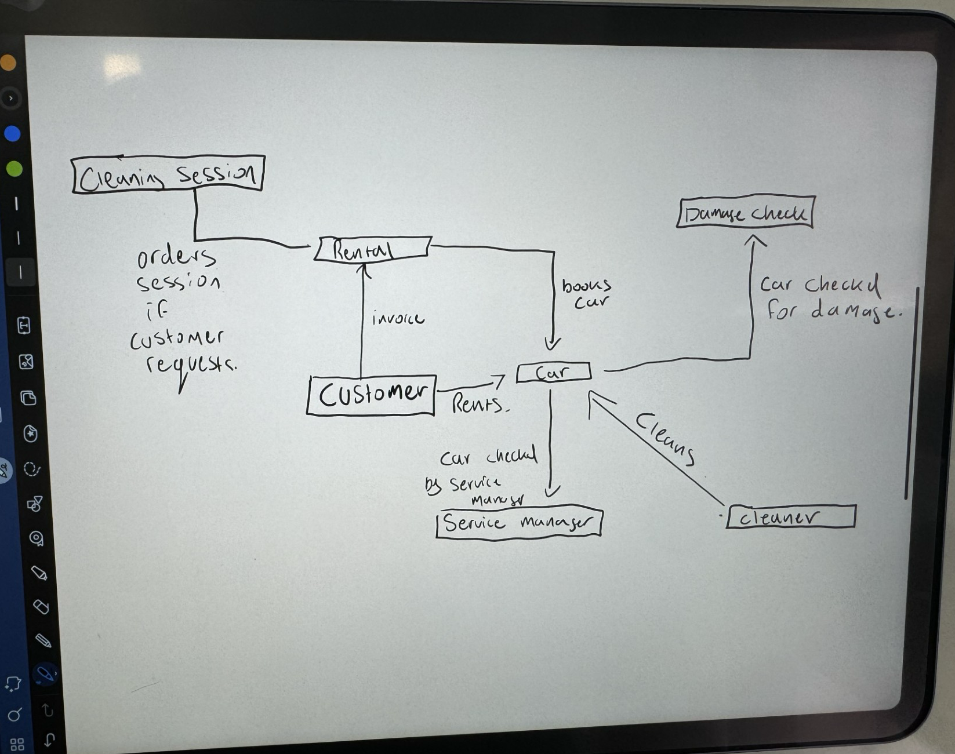

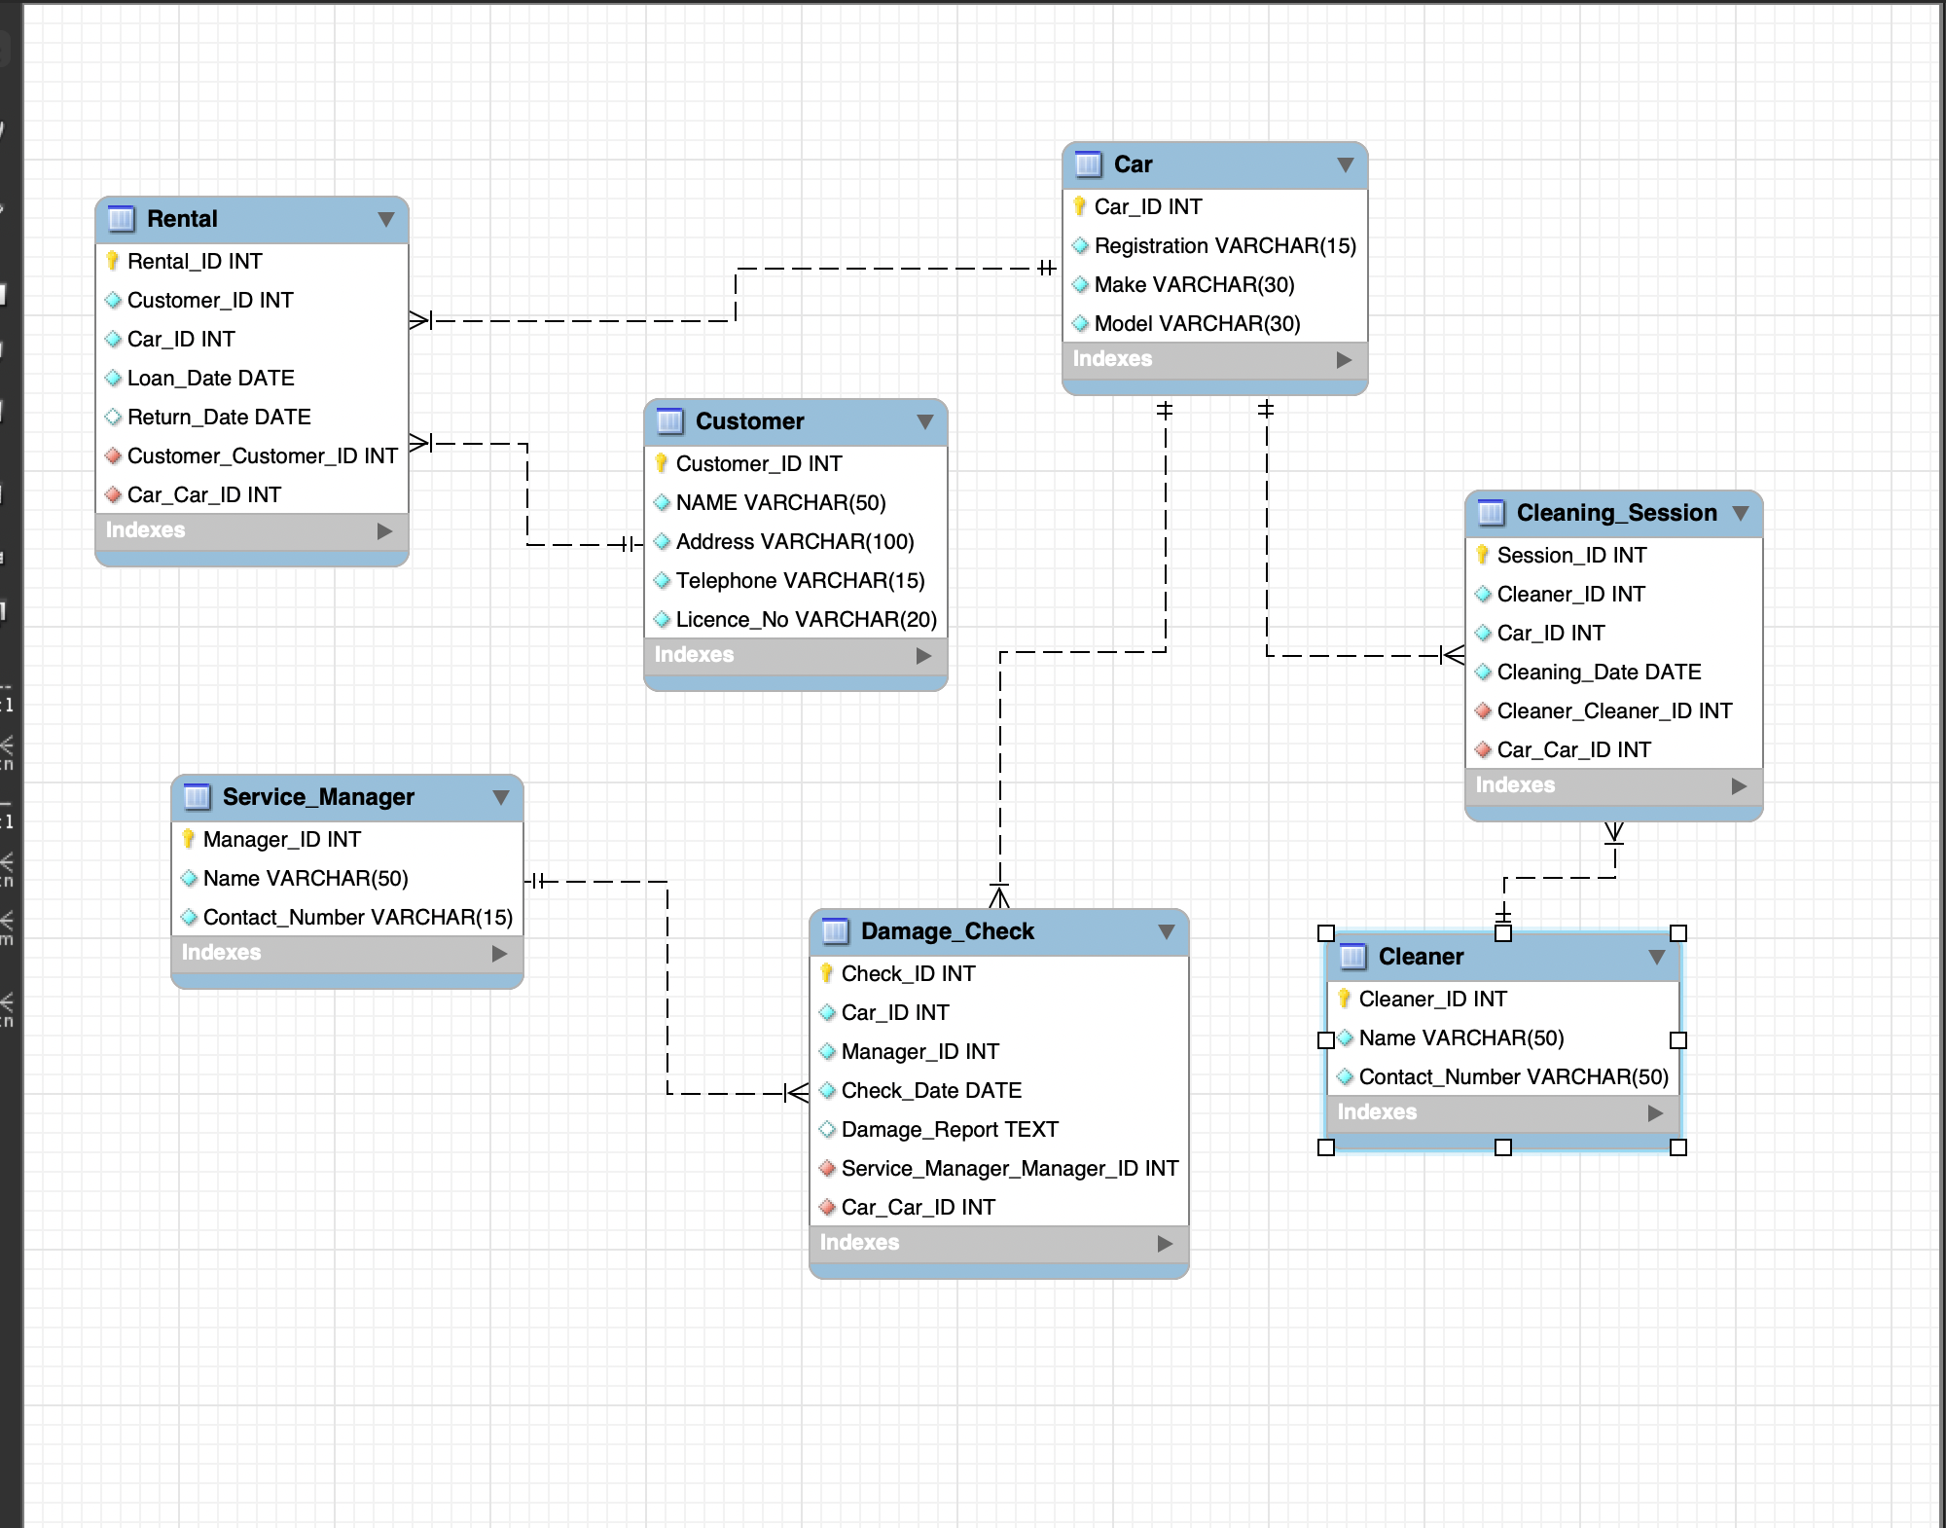

G7.2: Logical Model:
Convert the conceptual model to a logical model by adding attributes and keys (primary keys and foreign keys)

My G7.2:

I have Completed G7.2 as:
- Each table has a Primary Key (PK) (e.g., Customer_ID, Car_ID, Rental_ID).
- Relationships are enforced with Foreign Keys (FK):
  - Rental.Customer_ID → Customer.Customer_ID
  - Rental.Car_ID → Car.Car_ID
  - Damage_Check.Manager_ID → Service_Manager.Manager_ID
  - Cleaning_Session.Cleaner_ID → Cleaner.Cleaner_ID
Screenshot of Table structure descriptions:
After loading the EER db into my SQL I used DESC Customer; to see the table structure for one of my EER tables.
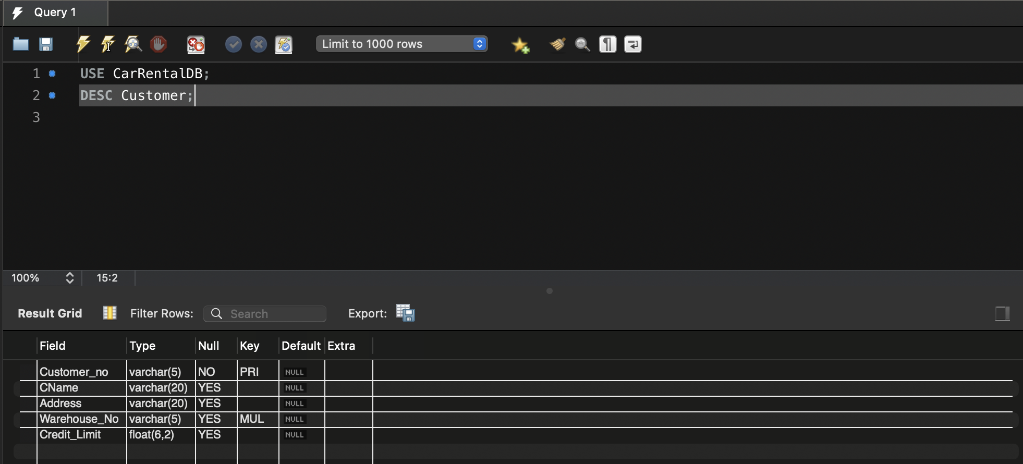

G7.3: Many to Many Decomposition:
Decompose one Many to Many relationship.

My G7.3:

I have Completed G7.3 as I showed:
- Many-to-Many Example: A Cleaner can clean multiple Cars, and a Car can be cleaned multiple times.
- Solution: I created the Cleaning_Session table to act as a junction table:
  - Cleaning_Session.Cleaner_ID → Cleaner.Cleaner_ID
  - Cleaning_Session. Car_ID → Car.Car_ID

Why cleaning session was needed and screenshot of my cleaning session EER Diagram:

In the Car Rental Database, a Cleaner can clean multiple Cars, and a Car can be cleaned multiple times by different Cleaners. This creates a Many-to-Many (M:N) relationship between Cleaner and Car.
Since MySQL does not support direct Many-to-Many relationships, we needed an intermediate table (Cleaning_Session) to break it down into two One-to-Many (1:M) relationships:
- A Cleaner can have multiple Cleaning Sessions → (Cleaner_ID in Cleaning_Session).
- A Car can be cleaned in multiple Cleaning Sessions → (Car_ID in Cleaning_Session).

